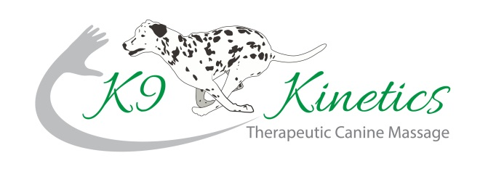
Samantha Kable
Tel: 07876 530554
sam@k9-kinetics.co.uk
www.k9-kinetics.co.uk
VETERINARY CONSENT FORM
Owners Name:
Address:
Telephone No:
Mobile No:
Email:
Dog’s Details
Name: |  | Breed: |  | Colour:
Sex: |  | DOB: |  | Neutered:
I Declare I am the legal owner of the above named dog and that all information presented is correct to the best of my knowledge. I give consent for my dog to be treated by Samantha Kable.
Owner Signature: …………………………………… Date: …………… ……………………
Veterinary Surgeon:
Practice Stamp – Address & Telephone No:
YOUR VET MUST COMPLETE AND SIGN THE AREA BELOW
Reason for approach, treatment, areas of concern:
Is the dog on any medication? YES/NO If yes, what?
In your opinion is the dog named above in a suitable state of health to undergo Massage Therapy? Yes/No
Signature of Veterinarian …….………………………………. Date ……………………
Samantha Kable respects the Veterinary Surgeons Act 1966 and Exemption Order 1962 by never working upon an animal without gaining prior veterinary approval.

